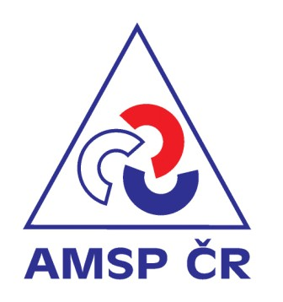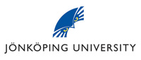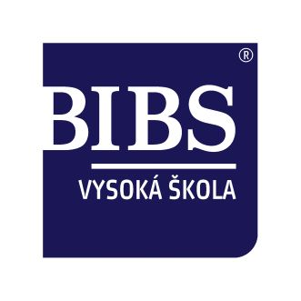

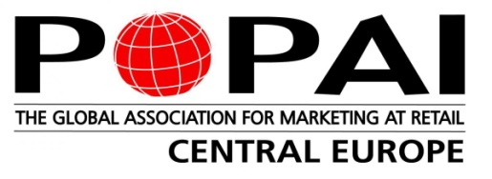

To suport development of private businesses in the Czech Republic and Slovakia, Brno International Business School (BIBS), AMSP ČR and POPAI CE would like to invite you, your friends and colleagues to join a unique workshop lectured by **Dr. Annika Hall from Jönköping University, Sweden.**

**„External management in privately owned companies“**

**Success factors making the collaboration between**

**owners and external managers work!**

**When:** Wednesday, **28th March** **2012**, 9.30 - 16.00 o’clock

**Where:** Brno International Business School (BIBS), Olbrachtova 5, 140 00 Prague

**Price:** Free of charge

**Language:** English

**Register:** until 21th of March 2012 at [foltynkova@bibs.cz](mailto:foltynkova@bibs.cz)

**Workshop background: A burning issue!**

The successful collaboration between an external managing director (MD) and the owners in privately owned companies is a burning issue. All over Europe a large number of private business owners are approaching retirement age. The question of transfer of ownership and/or leadership is therefore crucial. In the ongoing debate about business transfers in Europe (a topic that engage not only the business owners themselves, but also a large number of advisors, researchers, policy makers and even the EU[1] [2]) the focus has to a large extent been on either transfers within the family or a sale of the company to new owners. But many business owners are reluctant to sell their lifetime achievements. At the same time, there might be no one in the family (yet) willing and capable of taking over. In these cases an external MD (i.e. a non owner, non family member MD) might be a viable option. When the relationship between the external MD and the owner are constructive and functional, their efficient collaboration might lead to a releasing of an inherent growth and development potential of the business. This would not only benefit the business per se, but also the employees, customers, suppliers as well as the surrounding community in general.

**Content of seminar**

To be an external MD in a company where the owner has been MD (i.e. a former owner-managed firm) is an undertaking of huge challenges. Some of these challenges are no different from the challenges facing any MD. Other challenges are, however, unique. Owner-managed firms have a dynamic that is quite different from the dynamic of publicly listed companies. If, after the leadership transfer, the owner/former MD is still working on a daily basis in the company this increases the complexity of the transfer. Even more complexity is added if - which is not unusual - the same owner/former MD is also member of the executive board. In this situation in it absolutely essential that all parties understand and stick to their respective roles, in order for the collaboration to run smoothly.

The complexity and the pitfalls of the collaboration between an external MD and the owner are, however, often severely underrated. This tends to be due to a lack of knowledge about the specific challenges involved in a transfer of the MD role from the owner to a person external to the firm.

*The intention of this seminar is to provide knowledge that enhances the transfer and the further collaboration between the MD and the owner. The seminar will focus on important prerequisites for this kind of leadership transfer, as well as of how to successfully work with the challenges that inevitably arise.*

Some of the main issues/success factors covered by the seminar are:

* An explicit owners’ policy
* Clear MD instructions
* An active board
* Well defined roles for the owner(s)
* Cultural competence
* Trust
* Communication – one voice to the organization

The seminar will be interactive with many illustrations from practice. There will be room for discussions, reflection and questions. Advice in the form of “checklists” to external managers and owner will be provided.

**Target groups**

The seminar is relevant for owner of private businesses, and (future) external MD´s but also board members and consultants and other professional groups working with and for privately owned companies.

In order to succeed as *external MD* of an owner-managed company one has to understand the special dynamics of these organisations. This does not only imply a mere understanding of business related issues. The external MD must also have an understanding of more subtle issues related to the owners: what they want with their company, how strong their emotional attachment to the company is, and what their personal network looks like etc.

It is a main responsibility of the *owners* to make the recruitment successful. They have to carefully prepare the business for the transfer of leadership. Even more important – the owners have to prepare themselves of the inevitable changes the transfer will imply for them personally. For the owner the business is not merely a way of making money. It is rather a lifetime achievement and a personal identity. To let go of the position as MD therefore implies an emotional challenge. It is the owner’s responsibility to create conditions making it possible for the external MD to manage and further develop the business. It all comes down to a well functioning relationship, a constructive collaboration between owner and external MD – and it builds on mutual trust and understanding.

In addition to these two main target groups the seminar hasrelevance for recruitment companies, external board members and advisors/consultants.

**About Annika Hall**

Annika Hall is Associate Professor in business administration. She earned her PhD in 2003 with a thesis on family influence on corporate strategy in family firms. Annika Hall is currently affiliated with CeFEO (Centre for Family Enterprise and Ownership) at Jönköping International Business School. Her main interest is in the mutual influence of organization and individual(s) in the context of family firms. Her research focuses on how human motives and needs (i.e. values, relations, roles, identities) influence the interactions between individuals and, hence, organisational outcomes. She has published her work in books, edited books and journals, and presented her work at many international conferences.

Annika Hall has been awarded the Alden G. Lank award for best paper at the FBN world conference in Helsinki 2002, the Family Firm Institute’s award for best doctoral dissertation 2004 and the Family Firm Institute’s award for best unpublished research paper 2005. Hall has been the co-author of several commission research reports on transfer of ownership and leadership. She has been a guest teacher at several European Universities and Business Schools. She is an appreciated adviser and speaker to family firms, and as a co-worker of CeFEO she has taken an active part in developing and teaching “Active Ownership” an executive education program on ownership/leadership and ownership/leadership change in family owned businesses. During 2006-2007 Annika Hall was a board member of IFERA, the International Family Enterprise Research Academy.

*The seminar builds partly on the book (Swedish title): Extern VD -så lyckas du! 15 framgångsfaktorer för vd i ägarledda företag. ISBN 978-91-47-09546-9 (hardcover)No of pages: 160. The book is written by Annika Hall and Agneta Olsson. It is published by Liber AB (2010).*

1. 94/1069/EC: Commission Recommendation of 7 December 1994 on the transfer of small and medium-sized enterprises (Text with EEA relevance) Official Journal L 385, 31/12/1994 pp. 0014-0017.
2. Communication from the commission to the council, the European parliament, the European economic and social committee and the committee of the regions, implementing the Lisbon Community Program for Growth and Jobs Transfer of Businesses – Continuity through a new beginning, Brussels 14.03.2006 COM (2006) 117 final.